Pivot Tables

Teaching: 15 min

Exercises: 5 min

Questions

* How can I summarize large amounts of raw data?

Objectives

* Produce tables and charts that help you make sense of your data
* Edit your pivot tables

Trying to figure out large amounts of raw data can be overwhelming. With pivot tables, you can easily create interactive tables that summarize large data sets. They allow you to explore your data in different ways.

Building Pivot Tables

To build a pivot table:

1. Put your cursor anywhere in your data set, and then click Pivot Table on the Insert tab

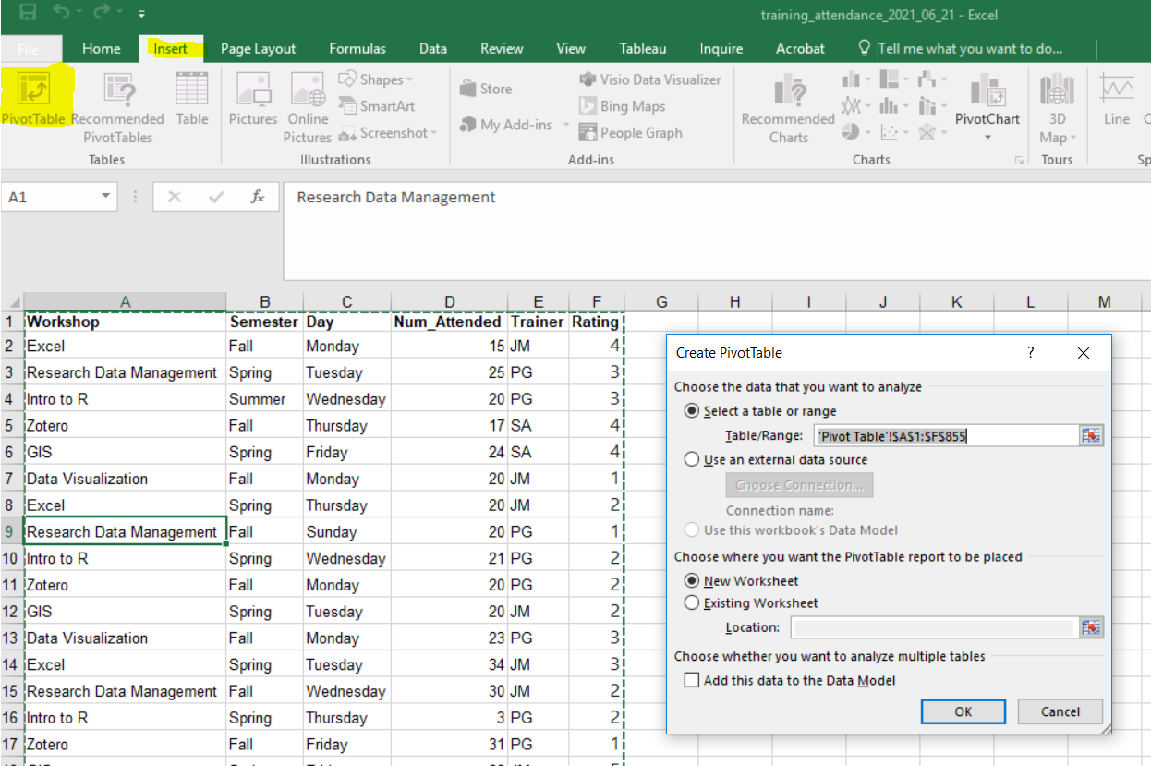

1. You will see the Create Pivot Table window. The default location for your pivot able will be a New Worksheet.
2. When you click Ok, you will go the new sheet, where the “Pivot Table Fields” pane also appears. Note that all our 6 fields (the headers in our original data set) are listed here.

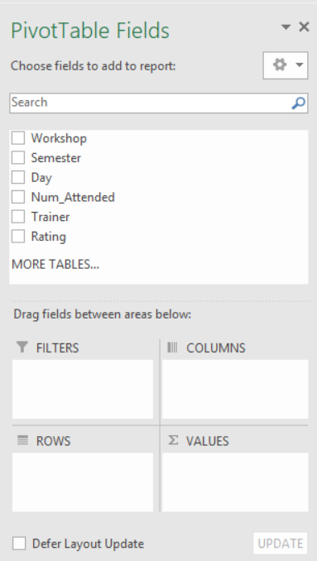

1. To build a pivot table, drag the fields into one the Filters, Columns, Rows, or Values areas.

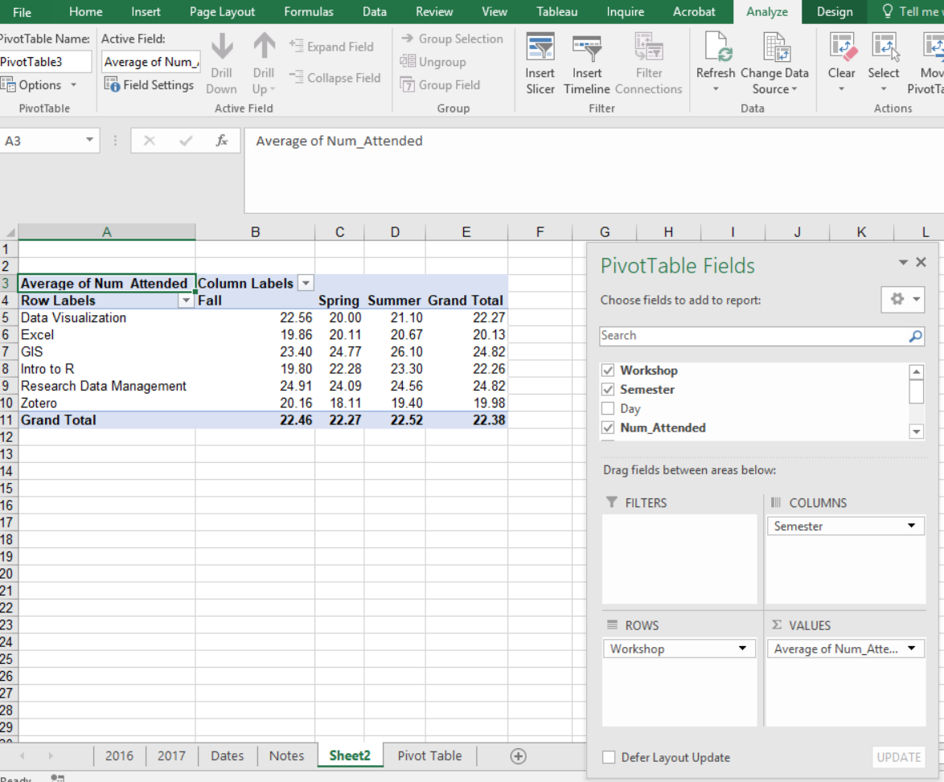

Formatting your Pivot Table

1. Click the pulldown arrow next to each item and click on Value Field Settings if you need to change the name of the field, how you would like to summarize your values, and/or change the values format.
2. You can sort and filter your pivot table by clicking the pulldown arrows next to Column Labels and Row Labels. In addition, you can get a cleaner table by clicking on the Field Headers button.

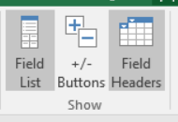

Keep in mind that if your raw data changes you will need to refresh your pivot table

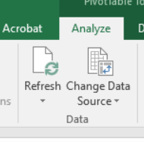

Finally, if you click PivotChart on the analyze tab, Excel will create an interactive Chart for your pivot table.

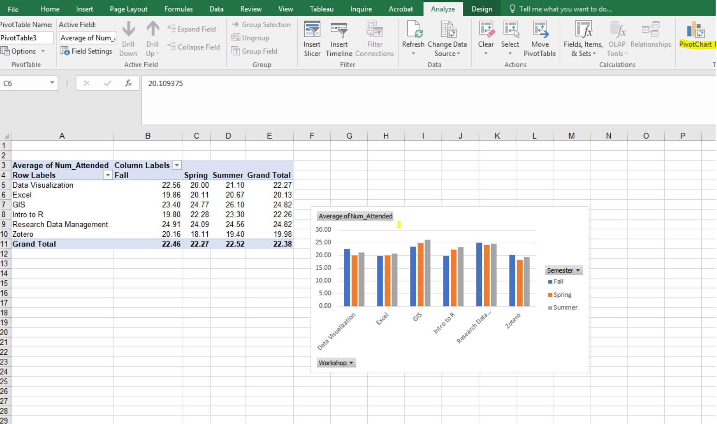

**Exercise**

Who is the instructor that taught more workshops on Fridays?

Solution

